Module 6-3 Adding a Temperature and Humidity Sensor
Russell Buck
CS 350 Emerging Sys Arch and Tech

Integrating the AHT20 temperature and humidity sensor with the Raspberry Pi and 16×2 LCD display helped reinforce how hardware, software, and state-based logic work together in an embedded system. After installing the required adafruit-circuitpython-ahtx0 package and wiring the sensor through the Qwiic connector, I verified basic readings using the provided test script. Once the sensor was confirmed to be functioning, I moved on to the full integration program.
The TemperatureSensorIntegration.py script uses a state machine to switch between Celsius and Fahrenheit whenever the button on GPIO 24 is pressed. The TempMachine class manages two states—Celsius and Fahrenheit—and updates the active scale accordingly. A separate display thread continuously refreshes the LCD, showing the current date and time on the first line and temperature and humidity on the second. The ManagedDisplay class handles all LCD communication, ensuring clean updates and proper cleanup on exit.
One challenge was understanding how the state machine and threading worked together, but reviewing the flow made it clear how each component contributed to smooth, real-time updates. Overall, this lab strengthened my confidence in integrating sensors, displays, and event-driven logic.
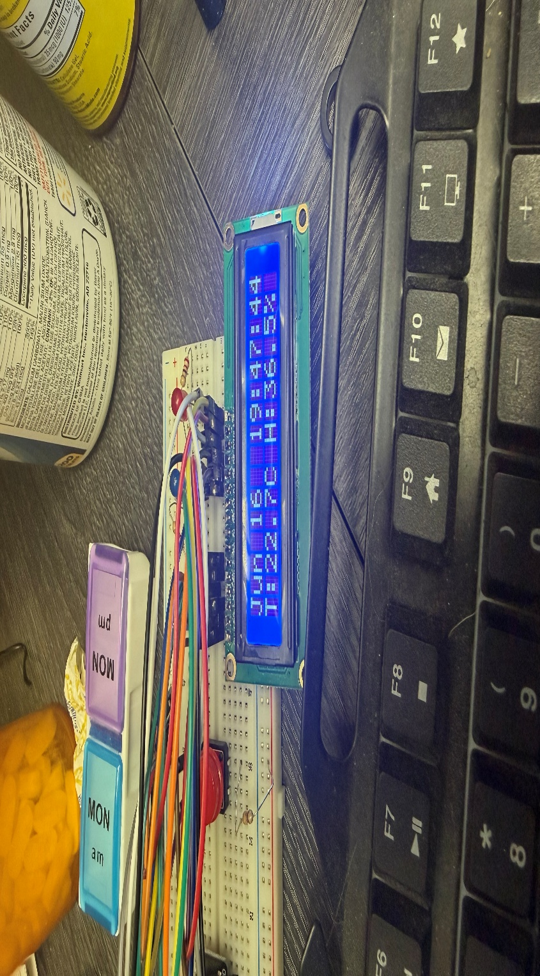
The above image shows the temperature and humidity showing clearly on the display.
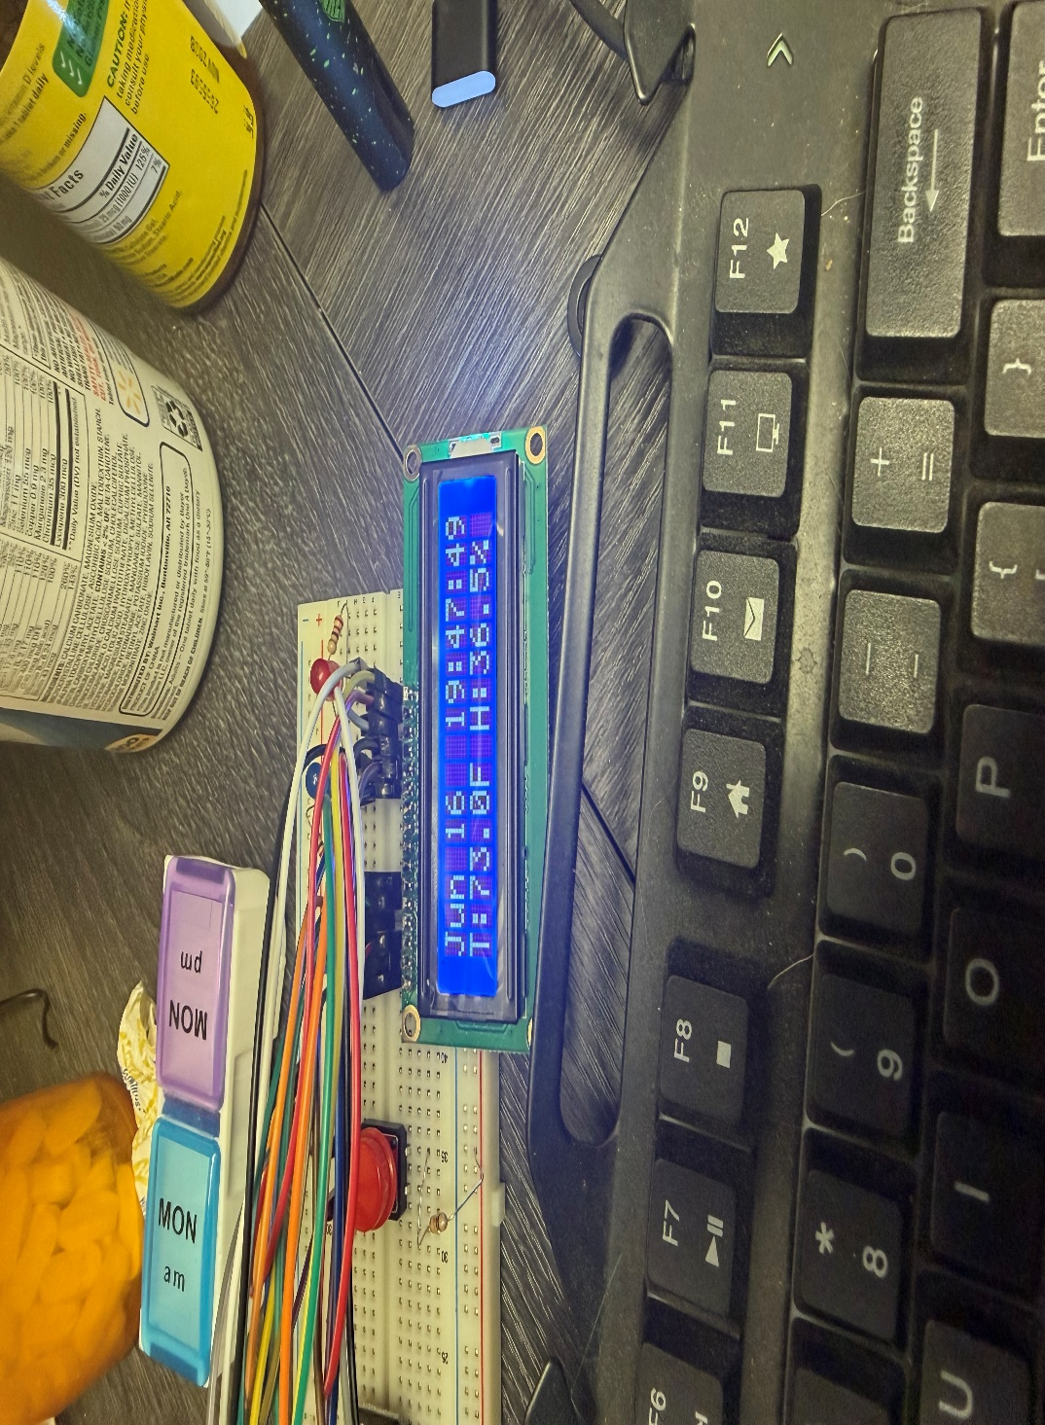
This image shows the temperature and humidity being shown on the display but after pushing the button to change to ferinheight.

